HandsOn Assignment:
Q.1)
ANS) SELECT MAX(salary) AS Maximum, MIN(salary) AS Minimum, SUM(salary) AS Sum, ROUND(AVG(salary)) AS Average FROM employees GROUP BY job_id;
Q.2)
ANS) SELECT ROUND(MAX(salary)) AS Maximum, ROUND(MIN(salary)) AS Minimum, ROUND(SUM(salary)) AS Sum, ROUND(AVG(salary)) AS Average FROM employees GROUP BY job_id;
Q.3)
ANS) SELECT job_id, ROUND(MIN(salary)) AS Minimum, ROUND(MAX(salary)) AS Maximum, ROUND(SUM(salary)) AS Sum, ROUND(AVG(salary)) AS Average FROM employees GROUP BY job_id;
Q.4)
ANS) SELECT job_id, COUNT(*) AS "Number of People FROM employees GROUP BY job_id;
Q.5)
ANS) SELECT COUNT(DISTINCT manager_id) AS "Number of Managers" FROM employees;
Q.6)
ANS) SELECT MAX(salary) - MIN(salary) AS DIFFERENCE FROM employees;
Q.7) 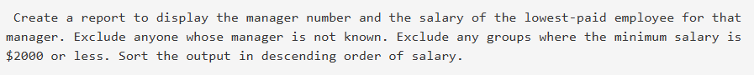
ANS) SELECT manager_id, MIN(salary) AS MIN_SALARY FROM employees WHERE manager_id IS NOT NULL GROUP BY manager_id HAVING MIN(salary) > 2000 ORDER BY MIN_SALARY DESC;
Q.8)
ANS) SELECT COUNT(*) AS "TOTAL",COUNT(DECODE(TO_CHAR(hire_date, 'YYYY'), '1980', 1)) AS "1980", COUNT(DECODE(TO_CHAR(hire_date, 'YYYY'), '1981', 1)) AS "1981", COUNT(DECODE(TO_CHAR(hire_date, 'YYYY'), '1982', 1)) AS "1982" FROM employees;

